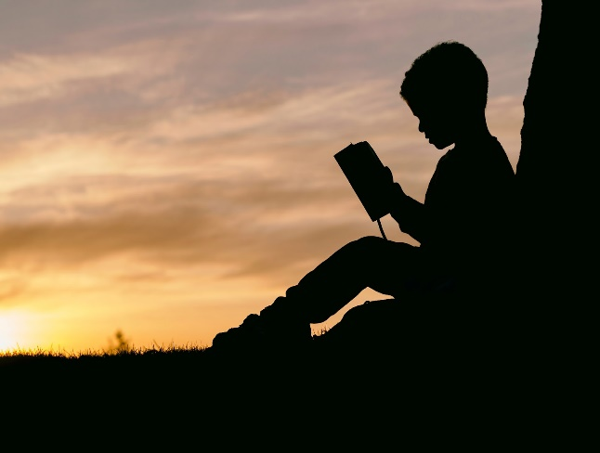
In reading
Your child should be able to:
- Read grade level texts closely to find main ideas and details.
- Compare texts on the same topic and ask and answer questions while elaborating on what others have said.
- When reading nonfiction, use illustrations, headings, captions, maps and diagrams to understand the text.
- Determine the meaning of words using context clues, prefixes (re, un, non) suffixes (s, es, ed) and root words.
- Use a known root word as a clue to the meaning of an unknown word with the same root (company/companion).
- Use glossaries or beginning dictionaries to clarify the meaning of key words and phrases.

In writing
Your child should be able to:
- Write for a variety of purposes including to inform, to persuade and to entertain.
- Select a topic of interest and write over an extended period of time.
- Create writing with a clear beginning, middle and end.
- Use proper spelling, punctuation and capitalization.
- Use multiple sources, such as books, internet and articles, to get information for writing.

In math
Your child should be able to:
- Write and solve problems involving multiplication and division fluently within 100.
- Use place value understanding and properties of operations to perform multi-digit arithmetic.
- Understand concepts of area and relate area to multiplication and addition.
- Develop an understanding of fractions as numbers.
- Compare fractions using a number line.
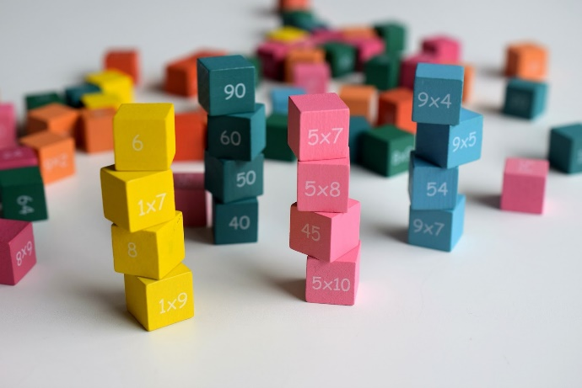
- Represent and interpret data.
- Reason about shapes and their attributes.

In science
Your child should understand:
- The difference between balanced and unbalanced forces and how unbalanced forces cause changes in motion.
- That magnets are a force that can cause motion without contact.
- That living things have inherited and environmental traits that help them survive in their environment.
- The difference between weather and climate and how to record weather patterns to make future predictions.

In social studies

Students will have been introduced to Michigan history and have used that as a way to study history, geography, civics, and economics.

