In reading
Your child should be able to read and understand narrative (stories) and informational (factual/science/social studies) text.
That means students should be able to:
- Identify the main purpose or meaning of what they read.
- Compare and contrast different passages or texts.
- Use parts of words or clues from the passage to figure out what new words mean.
- Locate information efficiently using text features like captions, headings, charts, and maps.
- Use academic vocabulary when reading, writing and speaking, and participate in small and large group discussion. Academic vocabulary includes words like grade level science and social studies terminology.

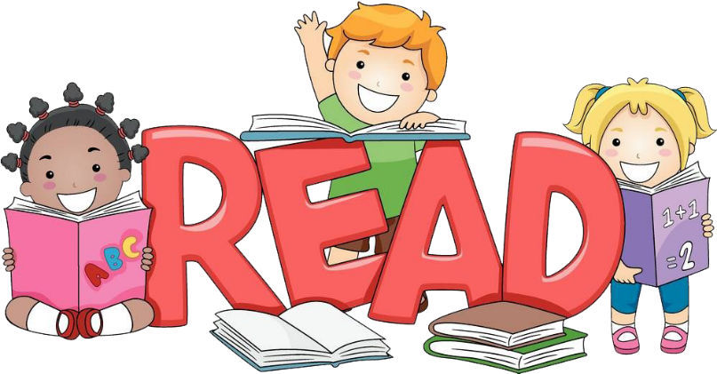

In writing
Your child should be able to write for different purposes - to entertain (tell stories), to voice an opinion, and to inform others.
- Story telling should include descriptive details.
- Opinion pieces should include supporting reasons.
- Informative writing should include facts and definitions, if needed.
- Writing should use correct spelling, punctuation and grammar.
- Using the writing process, your child can develop, organize, and share writing projects.

In math
By the end of second grade your child will be able to:
- Write and solve problems involving addition and subtraction within 1,000.
- Understand place value of up to 3-digit numbers (hundreds, tens, and ones).
- Measure lengths in standard units (centimeters and inches).
- Add and subtract 3 digit numbers.
- Tell time on digital and analog clocks.
- Find the value of a collection of dollar bills, quarters, dimes, nickels, and pennies.
- Partition shapes by halves, thirds, and quarters.

In science
By the end of the year, your child should understand:
- The different properties/states of matter.
- That plants need water and light to grow and rely on water, wind and animals to move seeds around.
- That plants and animals coexist together on land and in water.
- That wind and water change the shape of earth’s land quickly or slowly.

In social studies

Your child will have learned more about what a community is, human systems, maps, public issues and citizenship.

