In reading
Your child should be able to correctly read and use most words in a fifth grade level text. Students should also be able to:
- Read and comprehend a variety of narrative and informational texts.
- Ask and answer questions throughout the reading of a text.
- Summarize what they have read.
- Research a topic using at least three sources.
- Find information using text features such as captions, maps, and graphics.
- Use word parts to figure out the meaning of unknown words.
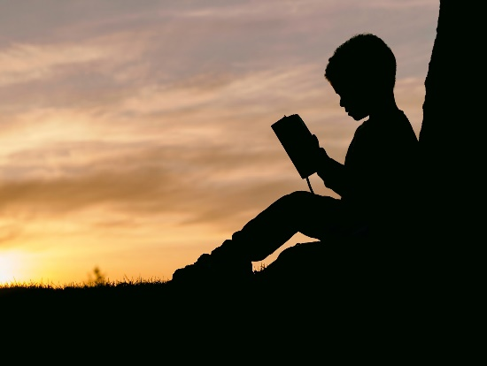
- Accurately use academic words.
- Make reading sound like talking.

In writing
Your child will continue to hone skills writing informational, opinion and narrative texts. Students should also be able to:
- Write for extended periods of time.
- Choose a topic of interest
- Write organized, multi-paragraph compositions with an introduction, body and conclusion.
- Write with descriptive details.
- Write in different forms such as reports, digital presentations, research and explanatory essays, and stories.
- Use a variety of sources to get information.
- Produce clear and coherent writing appropriate for the task, purpose and audience.
- Correctly use commas and quotation marks.

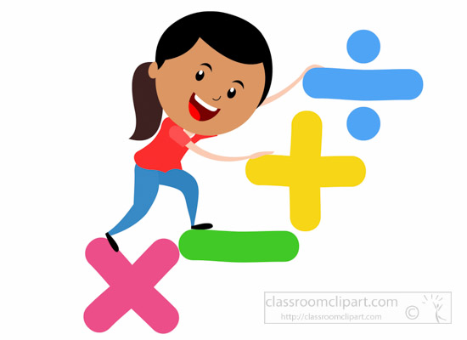

In math
Your child should be able to:
- Understand the place value system and be able to perform operations on multi-digit whole numbers and decimals to the thousandths place.
- Add and subtract using decimals and fractions with unlike denominators.
- Multiply and divide with whole numbers, decimals and fractions.
- Represent and solve word problems involving all operations.
- Understand volume and relate volume to addition and multiplication.
- Round decimals to thousandths place.

In science
Your child should be able to:
- Describe that matter is made of particles too small to be seen.
- Identify new substances after a chemical reaction has taken place.
- Understand how gravity works.
- Understand how plants make their own food through photosynthesis.
- Understand that energy is transferred from one organism to the next through a food chain and food web.

In social studies
This year your child will begin their study of American history, starting with the Native Americans before the Europeans explorers and continuing through the adoption of the Bill of Rights in 1791.

