In reading
Your child should be able to read fiction and non-fiction text at grade level with accuracy, fluency and comprehension. Students should be able to:

- Ask and answer questions about a text.
- Learn new vocabulary words.
- Determine a theme.
- Make inferences.
- Summarize text.

In writing
Your fourth grader should be able to write narrative, informational and opinion pieces using multiple paragraphs. The writing should contain punctuation, proper grammar, and rich word choices including a larger vocabulary and transitional words (next, likewise, additionally, etc.). Technology should be used for research and presentations.

In math
By the end of the year, your child should be able to:
- Fluently add and subtract multi-digit whole numbers.
- Write and solve problems involving multiplication of 2-digit x 2-digit and 1-digit x 4-digit numbers.
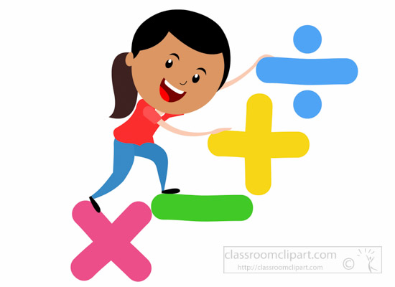
- Write and solve division problems involving up to 4-digit numbers divided by a single digit number.
- Fluently add and subtract fractions with like denominators.
- Fluently multiply fractions by a whole number.
- Round whole numbers up to hundred thousands.
- Understand the concept of angles and measure angles.
- Convert metric and customary units.

In science
Your child will understand that:
- Energy is present whenever there are moving objects, sound, light, or heat.
- Waves of the same type can differ in amplitude (height of the wave) and wavelength (spacing between wave peaks).
- Plants and animals have structures that help them grow and survive.
- Water, ice, wind, living organisms, and gravity break rocks, soils, and sediments into smaller particles and move them around.
- The locations of mountain ranges, deep ocean trenches, ocean floor structures, earthquakes, and volcanoes occur in patterns.

In social studies
Students will learn more about Michigan after it became a state. The study will include social studies concepts and how people interact within an increasingly complex social environment.

