First Grade Expectations
In reading
Your child will become a more independent reader and writer, better able to recognize and sound out words including some more complex words. Students should be able to:
- Sound out unfamiliar words.
- Participate in conversations about what is being studied and be able to ask questions to clear up any confusion.
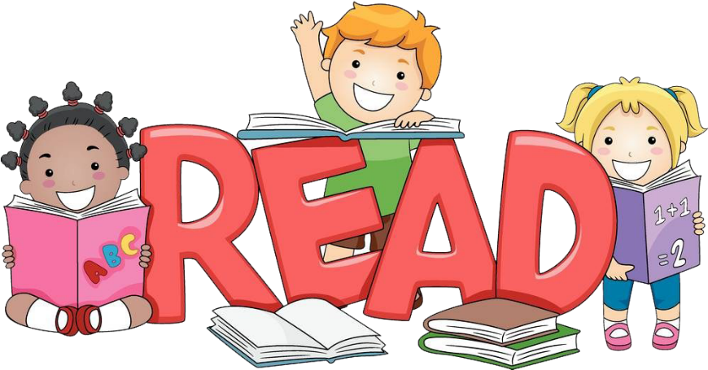
- Describe characters, settings and major events in a story including key details.
- Get facts and information from texts.
- Ask and answer questions about story texts.

In writing
Your child’s writing skills will also improve, including better spelling and using more complete sentences. Students should also be able to:
- Write opinion pieces where they introduce the topic, state an opinion, supply a reason for their opinion, and give some closing.
- Create informational pieces with a topic, information, and a closing.
- Write narratives with a sequence of events, some details, and a closure.

Grammar
Students should also be able to:
- Identify nouns, verbs and adjectives in sentences.

In math
Your child should be able to:
- Add, subtract, and solve problems involving addition and subtraction within 20.
- Count to 120.
- Tell time in hours and half hours using analog and digital clocks.
- Understand that a two-digit number represents the amount of tens and ones.
- Add and subtract 2-digit numbers without regrouping.
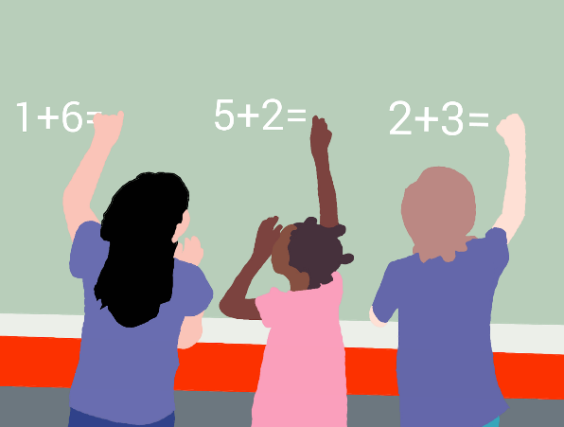
- Use non-standard units of measure (paper clips, cubes, etc.) to measure the length of objects.
- Reason about shapes and their attributes.
- Participate in numeracy tasks.

In science
Your child should know:
- Sound can make objects vibrate, and vibrating objects can make sound.
- Objects can be seen only if light is available.
- Adult plants and animals can have young. In many kinds of animals, parents do things to help their children survive.
- Objects in the sky (sun, moon, and stars) move in patterns that can be observed, described, and predicted.

In social studies
This year students will use the context of “School and Families” to learn social studies concepts like what is a family, roles and responsibilities of different people in a group, and why people work.

